

**Individual Report**

**Project Name:** Smart Parking

**Name of Student:** Sanglap Kundu

**Roll Number:** 1707046

**Name of concerned Faculty:** Prof. Satyadip Das

**Introduction**

Smart Parking means, a parking system where we can park our vehicles in a smart way. Here in this project what we have done is make a device which can help one to find right parking space on that parking place. Today in many cities there is many multi floor parking places and it’s very difficult to find a vacant place in this type of parking places, for this we introduced this project which helps to find vacant place for the vehicle very easily. In this project we used Internet of things and microcontroller which is Node-MCU, we also can use other micro controllers as well.

**HARDWARE & SOFTWARE**

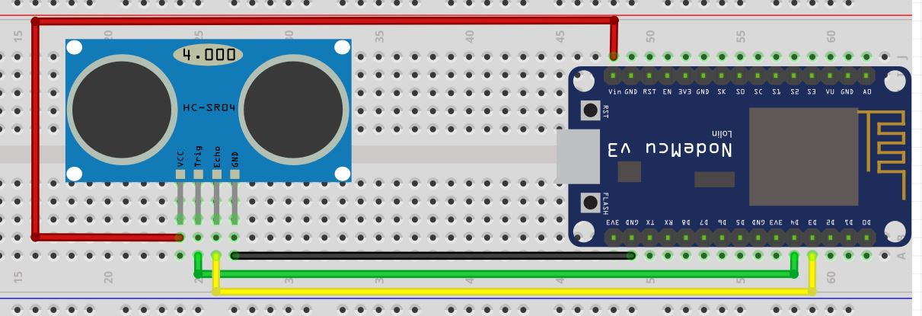

Fig: Circuit Diagram of Smart Parking

In this circuit Trigger is connected in GPO-2 which is D4, Echo is connected in GPO -2 which is D3.

Vcc is connected to Vin and Ground is connected to ground.

**Theory:** Here we apply the doppler principle, which says that if a certain amount of wave hit some object then it will return to the origin point, now if we catch this wave, we can calculate the distance and can find the presence of any object. Here the HC-SR04 does the same thing which mentioned in Doppler principle, trigger throws a signal and echo catches the returning signal.

**Coding Part:** The coding part is briefly explained on the main report.

**My Contribution:** I have done the main coding part with the help of Blynk cloud Library and slight of hardware mainly designing part using Fritzing. Blynk is a cloud-based service which is very easy to use as compare to other services like AWS, Firebase etc.

***Student Signature: Concerned Faculty Signature:***